**Microinjection**

Inject fluid (often cas9 + guides or morpholinos) into early stage zebrafish

Protocol overview

1. Day before injection, set cross in pairs w/ gates
2. Pull/cut/calibrate **needles**
3. Pull gates & tilt grates to allow mating to begin
4. Collect eggs, transfer to **injection mold**
5. **Inject** 1-cell embryos
6. Rinse injected embryos into a Petri dish. Add EM. Place injected embryos and sibling controls in incubator while other embryos are injected. Move to upstairs incubator.

Materials

* Injection mold
* Injection solution (whatever you’re injecting in 0.25% phenol red)
* Calibration slide
* Calibration chart
* Transfer pipettes
* Mineral oil
* Dumont #5 tweezers
* Pokers
* EM
* System water
* Egg strainer

Materials/equipment in the injection room:

* Borosilicate capillaries (Tritech Research #BF100-58-10 or GD-1) for pulling needles OR uncut needles OR cut needles
* Long-tip pipette tips
* Pipette
* Needle puller
* Manual pipette + wide pasture glass pipette tips
* Microscope
* Injecter + pressurized air
* Injection manipulator (optional)
* Incubator

**MORE DETAIL**

**Injection mold**

1. Prepare 1% agarose in nanopure H2O, 50mL
2. Poor into 10cm Petri dish, place plastic mold on top of hot agarose (ridge-side down)
3. Allow agarose to set
4. Remove plastic mold (use tape handle, or divot + pipette tip to lift up the plastic piece)
5. Cover agarose with EM, parafilm, date lid, store at 4C

    This can be used again and again so long as it stays in good shape. After use, rinse well with EM, cover with EM, parafilm, store at 4C

**Needles**

Cutting needles

1. Turn on needle-puller
2. Set program
   1. Program #5: ramp = 500, heat test ->heat = 600, pull = 45, vel = 75, time = 150
   2. 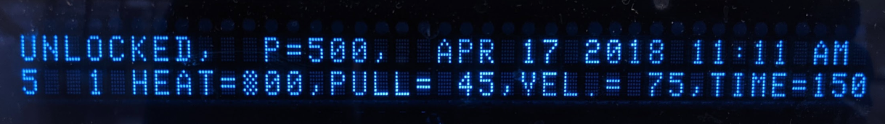
3. Load capillary
4. Close lid
5. Press start - filament will glow red as the capillary is heated. The arms of the puller will snap apart as the needle is formed.
6. Remove the two, newly pulled needles from the needle-puller, place in “uncut needles” Petri dish w/ clay inserts (clay is just meant to be a semi-sticky surface to keep the fragile needles from rolling around)
7. Freshly pulled needles are sealed shut and must be cut. Under the microscope, zoom into the ruler on the calibration slide. Place needle on slide to visualize diameter. Using tweezers to cut needle (downward pressure or pinching both work) so that tip is 0.01mm in diameter. Place cut needles in “cut needles” Petri dish w/ clay inserts

Loading needles

1. Using the pipette tip and a long tip, collect 1.8uL injection solution
2. Insert tip into cut needle
3. Eject solution as tip is removed
4. Insert needle into injection wand (there should be some resistance); tighten closure on wand to secure needle

 Calibrating needles

1. Open valve for pressurized air, turn on injector
2. Using a transfer pipette, place drop of mineral oil on the calibration slide
3. Under microscope, zoom in on calibration slide so that the ruler takes up the entire view
4. Place tip of loaded needle in mineral oil
5. If liquid is being taken up or expelled, adjust Pbalance (this is usually appropriately set; most of the time will not need adjustment)
6. Depress injector pedal to expel liquid
7. Determine desired drop diameter using the calibration chart… adjust Pinject until drop is of desired diameter

**Inject**

1. Remove liquid from injection mold
2. Transfer fertilized embryos to troughs of injection mold
3. Using poker, position embryos (for right-handers, ideal is cell to the left, yolk to the right)
4. Position needle near chorion, using gentle force, move needle through chorion and into yolk. Once positioned at junction between cell and yolk. Press injector pedal to expel liquid. An ideal injection expels liquid into the cell, not the yolk. Gently remove needle and repeat with remaining embryos

**IMAGES**

**Needle puller**

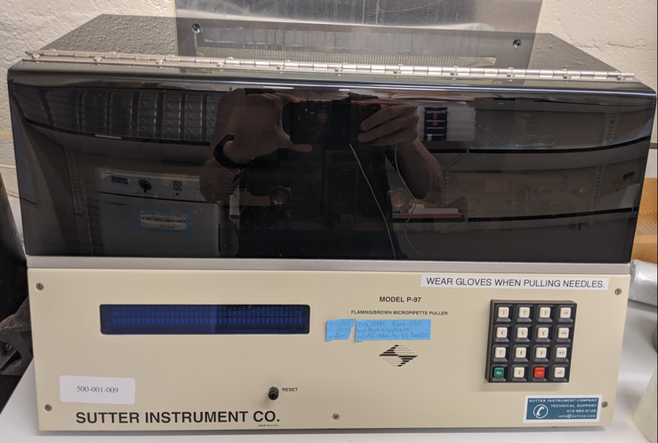

**Before cut:**

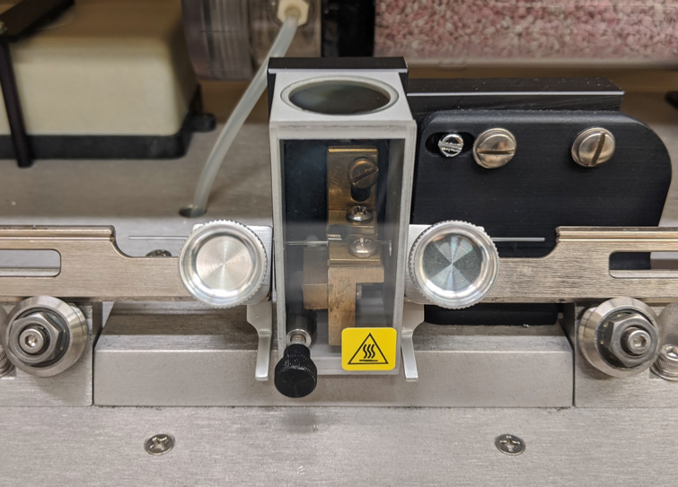

**After cut:**

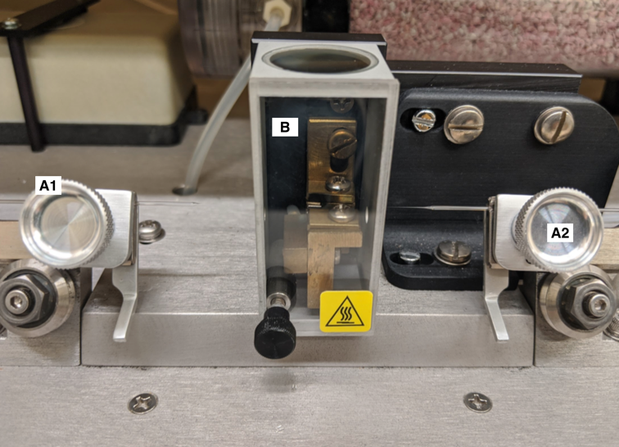

A - hold capillary in place

B - heated chamber

**Calibration slide**

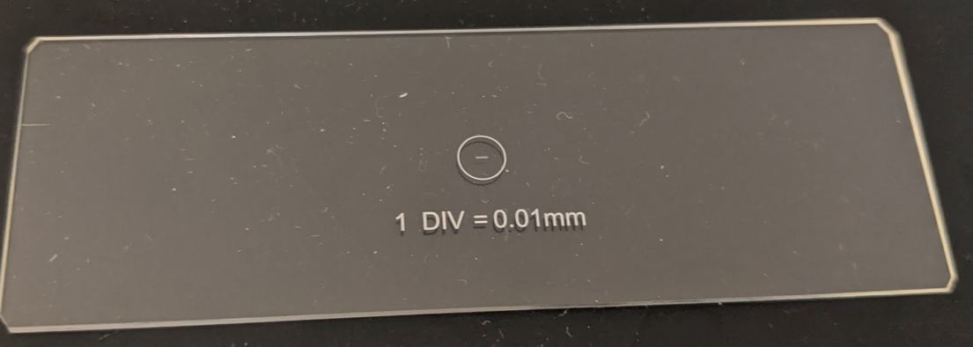

**Required materials**

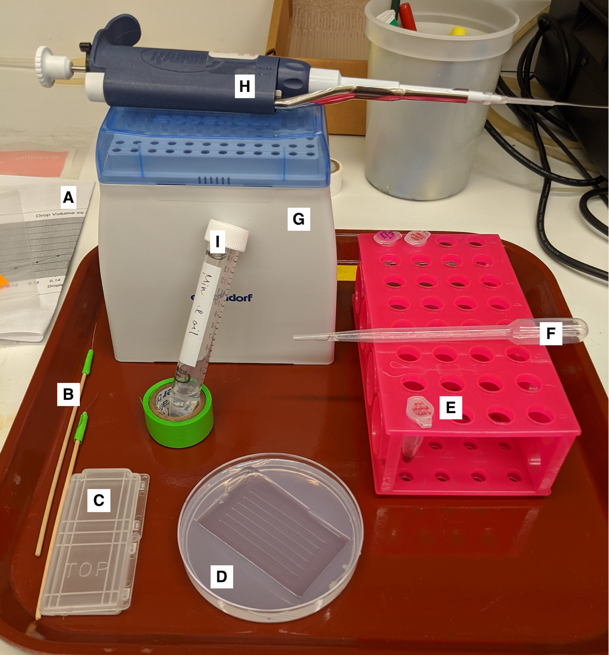

A - calibration chart

B - pokers (Monica style)

C - calibration slide

D - injection mold

E - injection solution (0.25% phenol red)

F - transfer pipette

G - long-tip pipette tips

H - pipette w/ long-tip pipette tips

I - mineral oil